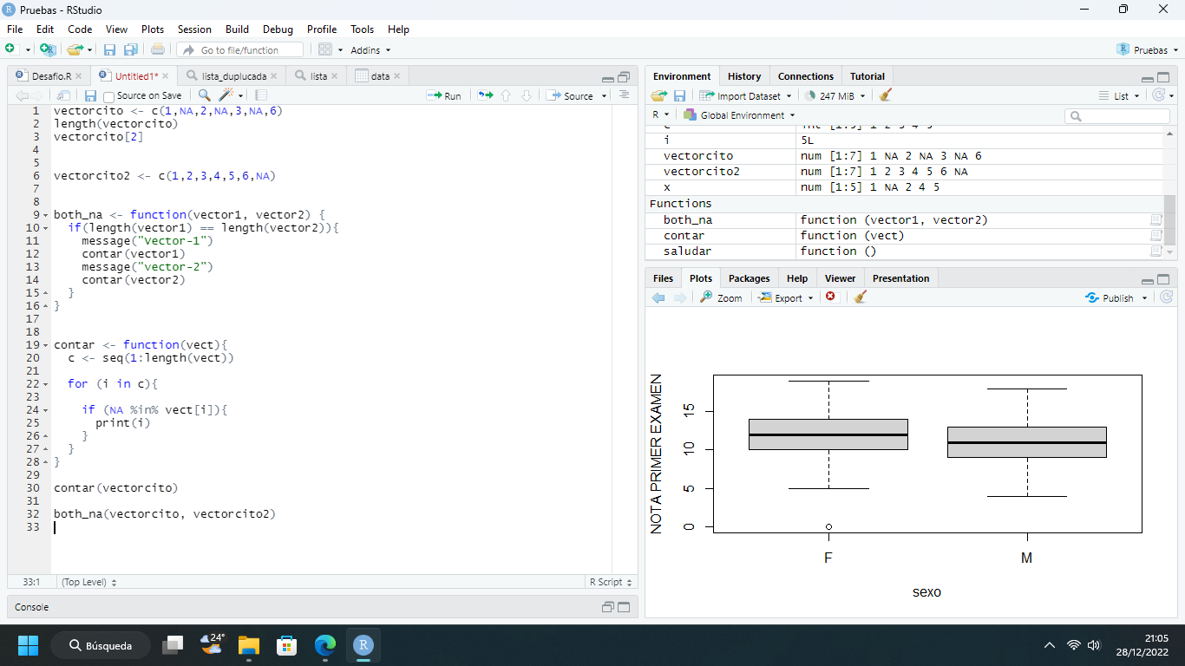

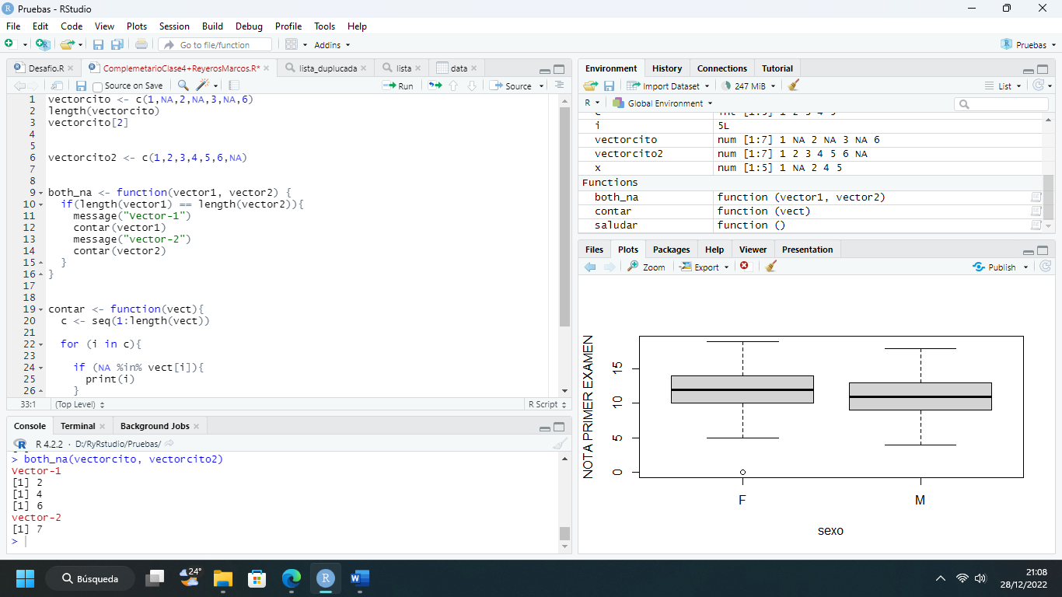

vectorcito <- c(1,NA,2,NA,3,NA,6)

length(vectorcito)

vectorcito[2]

vectorcito2 <- c(1,2,3,4,5,6,NA)

both_na <- function(vector1, vector2) {

if(length(vector1) == length(vector2)){

message("Vector-1")

contar(vector1)

message("vector-2")

contar(vector2)

}

}

contar <- function(vect){

c <- seq(1:length(vect))

for (i in c){

if (NA %in% vect[i]){

print(i)

}

}

}

contar(vectorcito)

both_na(vectorcito, vectorcito2)